How to Create Word Password and Remove it if Forgot

It is very common for MS Word documents contain sensitive information. Maybe you record your personal data such as bank information in it. Or, perhaps it contains your business data. Anyway, you will prefer to protect your confidential data from spying eyes. Creating a password is a featured function in Word program which is able to keep your documents safe from those unauthorized access.

Part I: How to create a password for Word document
Tips: If you have already known how to create Word password, directly go to Part II to see the directions on Word password remover.

The processes for creating Word password are a bit different depending on the version of it. Here we take Word 2007 for example.

Step 1: Open the Word document you would like to add a password to.
Step 2: Click “Microsoft Office Button” and select “Save as”->“Word Document”.
Step 3: In the Window of “Save as”, specify the location of your file. At the bottom of left corner, click on “Tools” and select “General Options”.
Step 4: You may now set a password under either “Password to open” box or “Password to modify” box or set passwords for both.
Step 5: Click “OK” to confirm your changes and save your document as usual.

Part II: How to Remove Word password if I forgot
Declare: This information is strictly shared to help you to gain access to your own Word document that you have lost or forgotten the password for.

After you create a password for your Word file, you don’t need to worry about security issue. But the troubles comes accidently, you forgot it. Not like Windows system password, Microsoft doesn’t empower you to retrieve Word password with built-in features. It is a bit hard to recover Word document unless you utilize Word Password Remover software.

Below are the easy steps on how to remove Word Password.

Step 1: Launch Word Password Remover and you will enter the user-friendly interface.

Step 2: Import password-encrypted Word document by clicking on “Open” and selecting the file on your PC.

Step 3: Choose “100% instant document decryption” which is recommended because it is the fastest and most efficient mode for Word password attacking. Click “Next”.

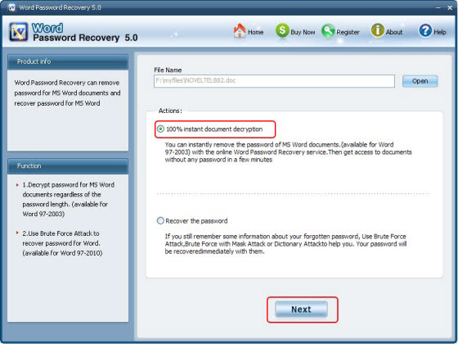

Step 4: Click on “Document Decryption” to initiate the recovery. After the recovery, a newly fixed file will be generated in the folder where your source file locates.

Done! You have removed Word password successfully.

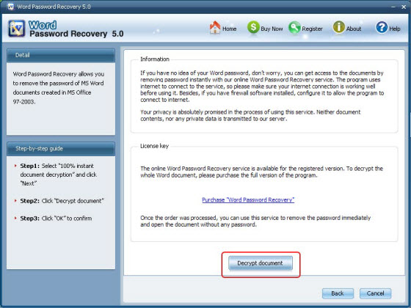

Article Source:
http://www.recoverlostpassword.com/article/word-password-remover.html

