How to use Word Password Recovery?
Word Password Recovery has 2 functions. This is the user guide for function 2.
1. 100% Instant Document Decryption (Online Password Remove Service)
2. Recover The Password (Offline and 3 types of attack)

100% Instant Document Decryption
Being urgent to use Word but forget the password? Take it easy, Word Password Recovery can remove password instantly with the online Word Password Remover service and get access to the documents without any password. It is available for documents created in MS Word 97-2003.

Follow the tutorial below to learn how to remove Word documents password.

Step1: Click "Open" to load Word document.
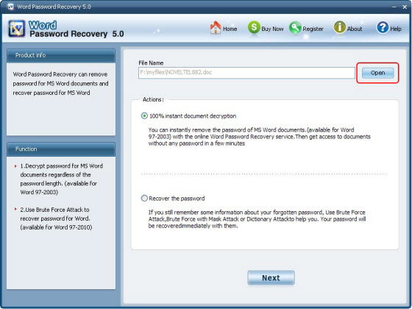
Step2. Select "100% instant document decryption" and click "Next".
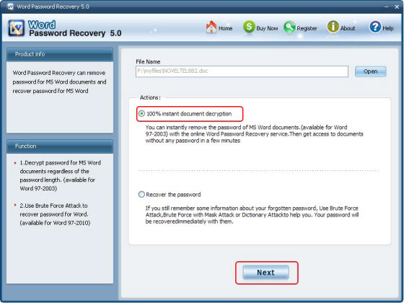
Step3. Click "Decrypt document" to remove Word password.
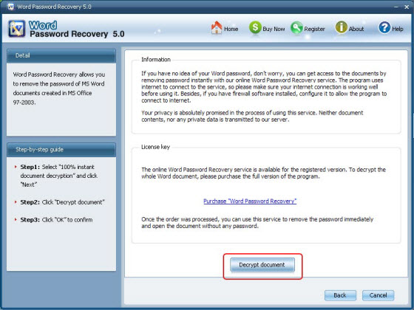
Step4. Remove Word file Password Successfully. The decryped file (*_Fixed.doc) has been automatically saved to the folder where your locked file is.
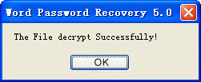
You can also click "Cancel" to stop decryption or click "Back" to continue other operation.
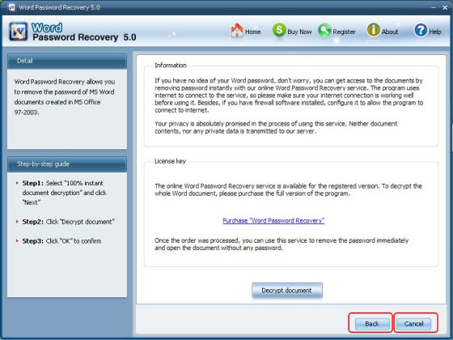
Note: The Word Password Remover tool uses internet to connect to the service, so make sure your internet connection is working well before using it. Besides, if you have firewall software installed, configure it to allow the program to connect to internet.

Recover Word Password
If you can remember some information about the lost or forgotten password, you can use Brute-force Attack to recover the password. Word Password Recovery provides three types of attack: Brute-force Attack, Brute-force with Mask Attack, Dictionary Attack. The program supports recovering password for Word file created in MS Word 97-2010.
Step1: Click "Open" to load the target Word file to the program.
Step2. Select "Recover the password" and click "Next"
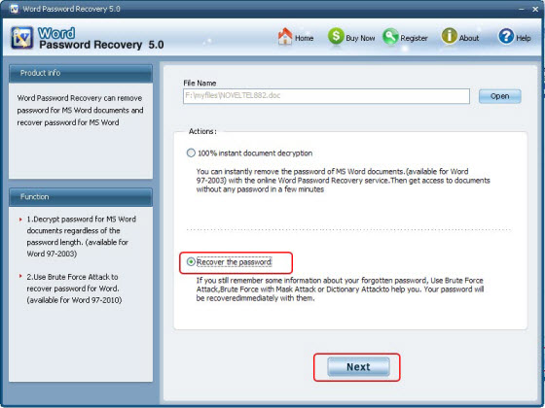
Step3. Select type of attack and click "Start"
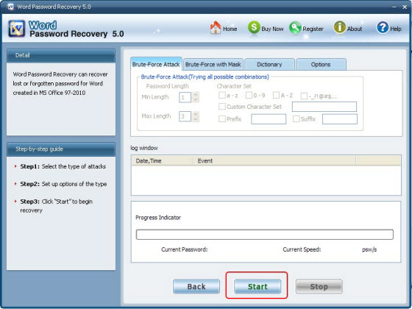
You can click "Stop" to stop operation or click "Back" to continue other operation.
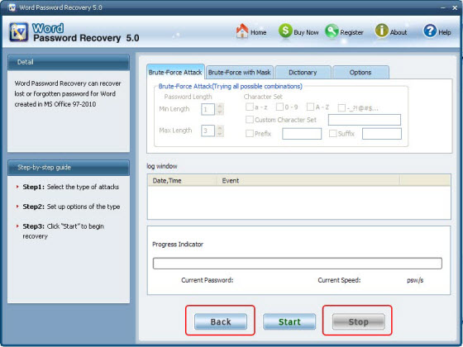
Step4. After clicking "Start" button, the program is recovering the Word password. Once the password is found, it'll be displayed in the File Opening Password Box. Use the password provided to open the Word file and view the information.
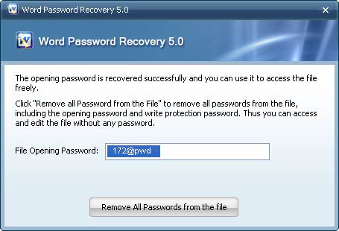

Know more about Word Password Remover Guide from:
http://www.recoverlostpassword.com/products/word-password-remover.html

Know more about Word Password Recovery Guide from:
http://www.recoverlostpassword.com/products/how_to_use_wordpr.html

