How to Remove Password from Word 2007?

Microsoft Word 2007 allows users to encrypt Word documents with a password for protection. In such a world with flooded information, for some certain purpose, it is quite necessary to protect the documents with passwords to keep information private and safe. If you decide that your document no longer requires a password, you can easily remove Word 2007 password.

Here is how to remove password from Word 2007 document?
In order to remove Word 2007 password, you'll need to open the document with its password. If you know it, then you just follow the below steps to go on.
Step1: Open the Microsoft Word 2007 document has been password-protected. Next it will ask you for the password. Then just enter the password and click OK to open it.
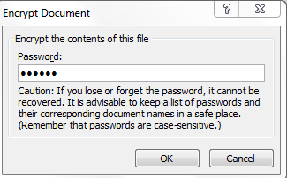
Step2: Click on the Office icon on the top left corner of the Word 2007 window.
Step3: Select “Prepare>>Encrypt Document. Then an Encrypt document dialog pops up with the password set (in asterisk).
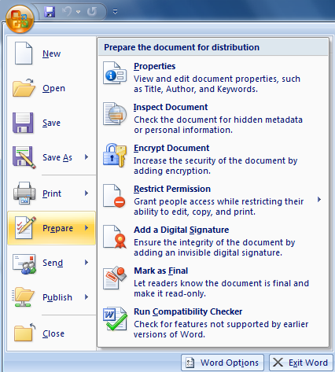
Step4: Clear the password and click OK.
Step5: Save and close the Word 2007 document.

But what if you forgot the password for your Word 2007 document, how would you clear password from Word 2007 in this situation?

Well, if that happens (forgetting Word 2007 password), Microsoft Office won’t help you clear the password. Well, you have to seek for a credible third-party Word password recovery application. There are two versions in Word password Recovery (Word Password Recovery Standard and Word Password Recovery Profession).

The crucial difference between Word Password Recovery Standard and Word Password Recovery Profession lies in time needed for getting your password back. Time is money, difficult to contradict this fact. And another proven fact is that you lose something exactly when something turns out to be absolutely necessary. So I would highly recommend you Word Password Recovery Professional. It has been successfully updated with the latest GPU support, which has further increased the speed of password recovery. In addition, with its Humanized design, I am sure that you can operate it with ease.

Here’s how to remove Word 2007 password with this tool.

Step1: Download Word Password Recovery Professional and then launch it quickly.
Step2: Click “Open” to load the target protected Word document.
Step3: You have 2 options in this step, choose one of them: 100% instant document decryption and Recover the password. Here we choose “100% instant document decryption” to remove Word 2007 password. Next, just click “Next” button to proceed.
Step4: Click “Decrypt Document” to begin clearing Word 2007 password.
(Note: Within seconds, the decrypted file (*_Fixed. docx) will be automatically saved to the folder where your locked file is.)

That’s all. 2 ways to remove Word 2007 password in both 2 different situations: having forgotten its password and having not forgotten it yet. However, you will find that the best way is to use Word Password Recovery Profession. Just download it, install it, and enjoy it!

Article Source:
http://www.recoverlostpassword.com/article/remove-word-2007-passowrd.html

