How to Hack a Password on Windows 7 with Software

Article Source:
http://www.recoverlostpassword.com/article/hack-windows-7-password.html

Believe or not, no matter if you’ve forgotten password for a Windows XP, Vista or even Windows 7 system, there are easy ways to get it back again. The problem is how? You may think of “hack”. Well, indeed, this article will show you how to hack Windows 7 password when you forgot or lost it. However, what I will show you—ways to crack lost Windows 7 computer password are all legal, they are not like what you think illegal “hack”. If you are doubting or even don’t believe, then just read over the passage, you will be persuaded.

Hack password for Windows 7 with professional third-party password recovery utility.
We all know if forget your computer password, Microsoft won’t offer you related service to solve the problem. Well, this really gives promising marketing chances to many software providers—providing the professional third-party password recovery applications. I cannot promise all of the third party password recovery applications are good ones, however, if I choose, I will trust Windows Password Recovery Professional. For no bug, no potential safety hazard, clean, and easy to use, instant to get back password etc., those are all good traits with the utility. Interested in it? Then let’s have a careful look over it!
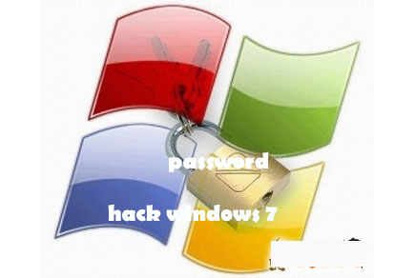

Guide on how to crack Windows 7 password with Windows Password Recovery Professional.
Step1: Download Windows Password Recovery Professional from SmartKey website.
Step2: Install and launch it to any accessible computer.
Step3: Use a blank and writable CD/DVD/USB to burn Windows 7 password reset disk with the tool.
Step4: Boot the locked computer from CD/DVD/USB.
Step5: Start to remove Windows 7 password with the burned disk.
Step6: Reboot computer and login to the locked PC without password.
No matter how complicated or how long your Windows 7 password is, this application—Windows Password Recovery Professional will instantly hack it within one minute! Only one minute later, you can regain access to your PC without limitation!

Change Windows 7 password with freeware—Ophcrack.
Ophcrack is an open source and free program that bypass Windows passwords by using LM hashes through rainbow tables. The Ophcrack Windows password reset is by far the fastest free Windows 7 password hacker tool available.
While compared with other professional Windows password recovery software, of course, Ophcrack, as a freeware, has some limitations. In the test on my Win 7 PC, Ophcrack can recover at most a 10-character password to my administrator account. Well, for the purpose of safety, I do recommend you to use a professional Windows password recovery tool.

